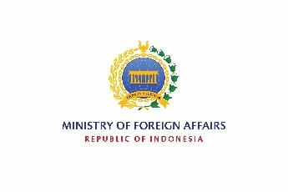
MINISTRY OF FOREIGN AFFAIRS OF THE REPUBLIC OF INDONESIA
DIRECTORATE GENERAL OF INFORMATION
AND PUBLIC DIPLOMACY
Jl. Taman Pejambon No. 6 Jakarta Pusat 10110

2023 INDONESIAN ARTS AND CULTURE SCHOLARSHIP

Application Form

A. Personal Details

1.Name
a. Family name / Surname
b. First or given name(s)

2.a. Date of birth
d | d | - | m | m | - | y | y
b. Place of birth

3. Sex Male Female

4. Nationality

5. Religion (optional)

6. Passport
a. Number
b. Date of issue
d | d | - | m | m | - | y | y
c. Valid until
d | d | - | m | m | - | y | y

7.a. Permanent address in home country

b. Telephone number (include country code)

c. e-mail address

8. Marital status Single Married Widowed Divorced

9.a. Occupation
b. Name of employer or school
c. Address of employer or school

10. Person to be notified in case of an emergency
a. In Indonesia
i. Name
ii. Relationship
iii. Address

iv. Telephone number

b. In home country
i. Name
ii. Relationship
iii. Address

iv. Telephone number

B. Academic Background

University / Higher Education Institution | Subject | Degree obtained / expected | Year

C. Language (insert ✓mark where appropriate)

 | None | Basic | Conversational | Fluent
Indonesian
English
Other (specify)

D. Professional History

Company / Organization | Position | Year

E. Travels

Countries | Reason | Year

F. Special Needs (allergies, food restrictions, etc.)
____________________________________________________________________________________________________________________________________________________________________________________________________________________

